

Windows Workflow Foundation

Hands-On Lab

Lab Manual
Lab 03 – Hosting the Windows Workflow Foundation Runtime in Visual Basic 2005

Converted from C# to Visual Basic.NET courtesy of:
Microsoft MVP Ken Kam Hung Lin.

Information in this document, including URL and other Internet Web site references, is subject to change without notice. This document supports a preliminary release of software that may be changed substantially prior to final commercial release, and is the proprietary information of Microsoft Corporation.

This document is for informational purposes only. MICROSOFT MAKES NO WARRANTIES, EITHER EXPRESS OR IMPLIED, AS TO THE INFORMATION IN THIS DOCUMENT.

The entire risk of the use or the results from the use of this document remains with the user. Complying with all applicable copyright laws is the responsibility of the user. Without limiting the rights under copyright, no part of this document may be reproduced, stored in or introduced into a retrieval system, or transmitted in any form or by any means (electronic, mechanical, photocopying, recording, or otherwise), or for any purpose, without the express written permission of Microsoft Corporation.

Microsoft may have patents, patent applications, trademarks, copyrights, or other intellectual property rights covering subject matter in this document. Except as expressly provided in any written license agreement from Microsoft, the furnishing of this document does not give you any license to these patents, trademarks, copyrights, or other intellectual property.

Unless otherwise noted, the example companies, organizations, products, domain names, e-mail addresses, logos, people, places and events depicted herein are fictitious, and no association with any real company, organization, product, domain name, email address, logo, person, place or event is intended or should be inferred.

© 2007 Microsoft Corporation. All rights reserved.

Microsoft, MS-DOS, Windows, Windows NT, Windows Server, SQL Server, Visual Basic 2005 and Visual Studio are either registered trademarks or trademarks of Microsoft Corporation in the United States and/or other countries.

The names of actual companies and products mentioned herein may be the trademarks of their respective owners.

Contents
Lab 03: Hosting the Windows Workflow Foundation Runtime 1
Lab Objective 1
Exercise 1 – Hosting the Workflow Runtime 1
Task 1 – Create a new Console Application Project 1
Task 2 – Listen for Runtime Events 4
Task 3 – Configuring Runtime Services 7
Exercise 2 – Using the default SQL Services 11
Task 1 – Create a new Console Application Project. 11
Task 2 – Adding the SQLTrackingService to the host environment 13
Task 3 – Adding the SQLPersistenceService to the host environment 15
Task 4 – Adding a WorkflowSchedulerService to the host environment 19
Exercise 3 – Building a Custom TrackingService for Workflow Monitoring 22
Task 1 – Create a new Console Application Project 22
Task 2 – Create our ConsoleTrackingChannel 23
Task 3 – Create our ConsoleTrackingService 26
Task 4 – Run ConsoleTrackingServiceSample 28

Lab 03: Hosting the Windows Workflow Foundation Runtime
Estimated time to complete this lab: 60 minutes
The project files for this lab are in the c:\Windows Workflow Foundation\Labs\VB\Lab03 folder

Lab Objective
The objective of this lab is to introduce you to hosting the Windows Workflow Foundation runtime. After completing this lab, you will be able to:
- Host the workflow runtime in a simple Windows console application and run a workflow using the workflow runtime.
- Run the console application to verify that workflow was loaded, ran successfully and that the runtime events are raised.
- Use the SQL Tracking, SQL Persistence and WorkflowSchedulerService service to log workflow and runtime related events.
- Use an app.config file to tailor the runtime environment to meet your needs.

Note:
Please execute c:\Windows Workflow Foundation\Labs\VB\Lab03\Resources\CreateDatabaseObjects.cmd to install the appropriate database tables onto Either Sql Server 2005 or Sql Express

Exercise 1 – Hosting the Workflow Runtime

In this exercise you will create a simple console application to instantiate the workflow runtime and start a workflow.

Task 1 – Create a new Console Application Project

- Open Visual Studio 2005 by going to the Start Menu | All Programs | Microsoft Visual Studio 2005 | Microsoft Visual Studio 2005
- In Visual Studio 2005, select the File | New | Project menu command.
- Visual Studio will display the New Project dialog window.
- In the New Project dialog window, expand Visual Basic | Workflow in the Project Types tree on the left side.
- Select Sequential Workflow Console Application change the location to c:\Windows Workflow Foundation\Labs\VB\Lab03\.

Name: HostingWorkflowRuntime

Location: C:\Windows Workflow Foundation\Labs\VB\Lab03\

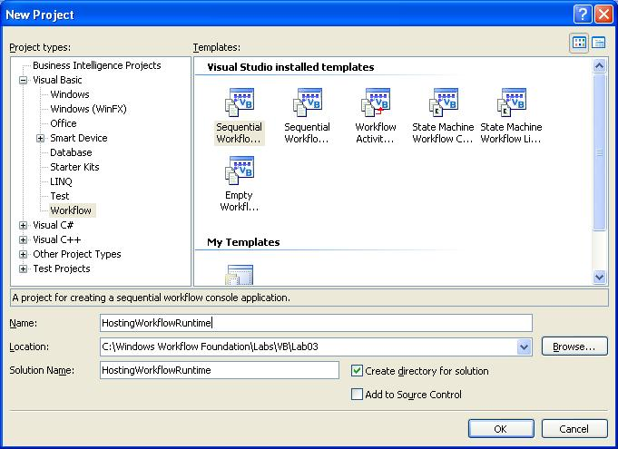
- Click OK to create the new solution.
- Right Click on Workflow1.vb in the solution explorer and Rename it to SimpleWorkflow.vb.

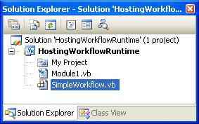

- Press Yes if prompted to rename all instances of Workflow1

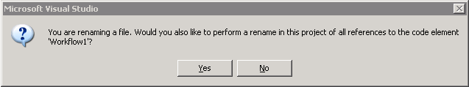

- Double click on SimpleWorkflow.vb to view the designer, and drop a Code activity on the workflow where it states Drop Activities to create a Sequential Workflow.
- Set the (Name) property on the new Code activity to working.

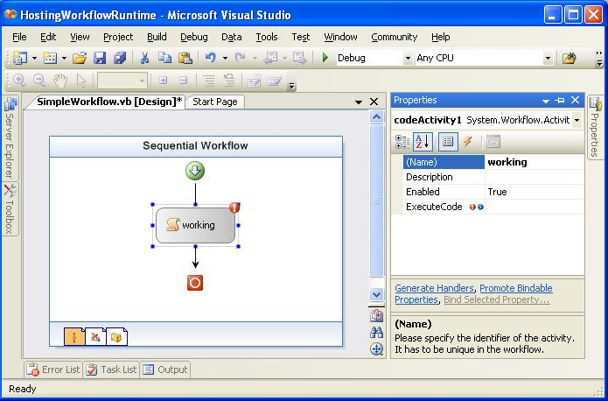

- Double click on the working Code activity, to produce a default event handler.
- When the workflow is executed the code handler for working will be called so let's just add a simple Console.WriteLine statement to working_ExecuteCode so that we know the function was called. Add the line highlighted in gray:
Private Sub working_ExecuteCode(ByVal sender As System.Object, ByVal e As System.EventArgs)
Console.WriteLine("Here in Working_ExecuteCode.")
End Sub

- Select the console application code by clicking on Module1.vb in the solution explorer and pressing the View Code button on the toolbar.

- The code already generated in Main is all we need to create an instance of the workflow and run it. However, it will complete and exit before you have a chance to see what it displayed. Insert the following grey highlighted two lines of code after starting the workflow instance and waiting. Remember to insert some white space at the place where you wish the snippet to go.

(Snippet: “Lab03 Ex01 Task01 PauseExecute”)

workflowInstance.Start()
WaitHandle.WaitOne()
Console.WriteLine("Workflow Completed - press ENTER to continue")
Console.Read()
- Now select the Build | Build Solution menu command to compile and build your project. Verify that there are no compiler errors or warnings. If all goes well then press F5 to run the console application. You should see the following…

- As we have inserted a Console.Read() in as the last line in the application the console will wait for you to press Enter before it will exits.

Next we will look at some of the runtime events you can subscribe to. In addition we will look at the logging built into the runtime that you can use to keep track of what is going on. We will start with runtime events.

Task 2 – Listen for Runtime Events

- There are a number of things we can do as the host to either control the runtime environment or be informed about what is happening. In this task we will subscribe to some runtime events. Let’s start by subscribing to the runtime’s Started and Stopped events. Add the following two lines of code highlighted in gray to the Main method below the existing delegates. Remember to insert some white space at the place where you wish the snippet to go.

(Snippet: “Lab03 Ex01 Task02 Delegates1”)

…
AddHandler workflowRuntime.WorkflowCompleted, AddressOf OnWorkflowCompleted
AddHandler workflowRuntime.WorkflowTerminated, AddressOf OnWorkflowTerminated
AddHandler workflowRuntime.Started, AddressOf workflowRuntime_Started
AddHandler workflowRuntime.Stopped, AddressOf workflowRuntime_Stopped
Dim workflowInstance As WorkflowInstance
…

- Next insert the event handler methods for the above delegates inside the Program class below the Main method. In the workflowRuntime_Started method we cast the sender parameter to a WorkflowRuntime variable so that we can get a collection of all the services loaded by the workflow runtime. We then use foreach to print them to the console. We also add a Console.WriteLine statement to the workflowRuntime_Stopped method, Remember to insert some white space at the place where you wish the snippet to go.

(Snippet: “Lab03 Ex01 Task02 EventHandler1”)
Shared Sub workflowRuntime_Stopped(ByVal sender As Object, ByVal e As WorkflowRuntimeEventArgs)
Console.WriteLine("Runtime stopped event.")
End Sub

Shared Sub workflowRuntime_Started(ByVal sender As Object, ByVal e As WorkflowRuntimeEventArgs)
Dim w As WorkflowRuntime = CType(sender, WorkflowRuntime)
Dim services As ICollection = w.GetAllServices(GetType(System.Object))
For Each o As Object In services
Console.WriteLine("Service of type " & o.ToString & " started.")
Next
End Sub
- The code in workflowRuntime_Started will print all the services being hosted by the workflow runtime. Press F5 to run the console application, typically you will see something like the following:

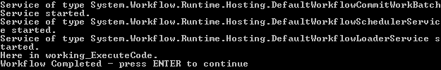

- Let’s add some additional events we want to be notified about. Subscribe to the WorkflowResumed and WorkflowSuspended events. There are others you can look at but for now let's just look at these additional two. Insert the following code below the existing delegates to subscribe to these event handlers:

(Snippet: “Lab03 Ex01 Task02 Delegates2”)

AddHandler workflowRuntime.Started, AddressOf workflowRuntime_Started
AddHandler workflowRuntime.Stopped, AddressOf workflowRuntime_Stopped
AddHandler workflowRuntime.WorkflowResumed, AddressOf workflowRuntime_WorkflowResumed
AddHandler workflowRuntime.WorkflowSuspended, AddressOf workflowRuntime_WorkflowSuspended
- Next insert the event handler methods for the above delegates inside the Program class.

(Snippet: “Lab03 Ex01 Task02 EventHandler2”)
Shared Sub workflowRuntime_WorkflowSuspended(ByVal sender As Object, _
ByVal e As WorkflowSuspendedEventArgs)
Console.WriteLine("In WorkflowSuspended, reason: " & e.Error)
End Sub

Shared Sub workflowRuntime_WorkflowResumed(ByVal sender As Object, ByVal e As WorkflowEventArgs)
Console.WriteLine("In WorkflowResumed")
End Sub
- Now make a few changes to Main. The call to Suspend takes a string as a parameter. This string will be available in the WorkflowSuspended event as part of the WorkflowSuspendedEventArgs. Add the two lines of code highlighted in gray:

(Snippet: “Lab03 Ex01 Task02 SuspendResume”)
Dim workflowInstance As WorkflowInstance
workflowInstance = workflowRuntime.CreateWorkflow(GetType(SimpleWorkflow))
workflowInstance.Start()

workflowInstance.Suspend("Reason we are suspending the workflow.")
workflowInstance.Resume()
WaitHandle.WaitOne()

- Compile and run the application and you should see something like this:.

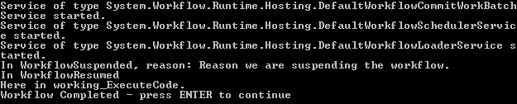

There are a couple of ways that the host can set up the runtime environment. It can use an App.Config file that contains the settings for the runtime to use. Alternatively it can use the WorkflowRuntime.AddService and WorkflowRuntime.RemoveService methods.

Task 3 – Configuring Runtime Services

- We can change the behavior of the runtime by adding a config file,
- Add a Application Configuration file by, right clicking on HostingWorkflowRuntime project, select Add | New Item, and choose Application Configuration File

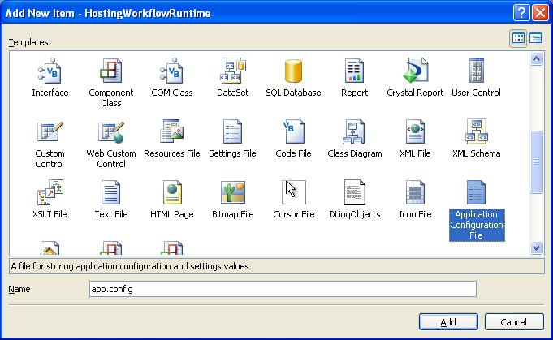

- Overwrite the contents of the App.Config file with the following file, C:\Windows Workflow Foundation\Labs\VB\Lab03\Resources\application configuration file.txt

<?xml version="1.0" encoding="utf-8" ?>
<configuration>
<configSections>
<section name="ConsoleApplication"
type="System.Workflow.Runtime.Configuration.WorkflowRuntimeSection,
System.Workflow.Runtime, Version=3.0.00000.0, Culture=neutral,
PublicKeyToken=31bf3856ad364e35" />
</configSections>
<ConsoleApplication Name="WorkflowConsoleApplication1">
<CommonParameters>
<add name="ConnectionString" value="Initial Catalog=TrackingStore;
Data Source=localhost\SQLExpress;
Integrated Security=SSPI;" />
</CommonParameters>
<Services>
<add type="System.Workflow.Runtime.Hosting.DefaultWorkflowSchedulerService,
System.Workflow.Runtime,
Version=3.0.00000.0, Culture=neutral,
PublicKeyToken=31bf3856ad364e35" />
<add type="System.Workflow.Runtime.Hosting. SharedConnectionWorkflowCommitWorkBatchService,
System.Workflow.Runtime,
Version=3.0.00000.0, Culture=neutral,
PublicKeyToken=31bf3856ad364e35" />
<add type="System.Workflow.Runtime.Hosting.SqlWorkflowPersistenceService,
System.Workflow.Runtime,
Version=3.0.00000.0, Culture=neutral,
PublicKeyToken=31bf3856ad364e35" />
<add type="System.Workflow.Runtime.Tracking.SqlTrackingService,
System.Workflow.Runtime,
Version=3.0.00000.0, Culture=neutral,
PublicKeyToken=31bf3856ad364e35" IsTransactional="true"
UseDefaultProfile="true" />
</Services>
</ConsoleApplication>
<system.diagnostics>
<switches>
<add name="WorkflowTraceToDefault" value="1" />
<add name="Host" value="All" />
<add name="Runtime" value="All" />
<add name="Tracking" value="All" />
<add name="Activity" value="All" />
</switches>
<trace autoflush="true" indentsize="4">
<listeners>
<add name="myListener"
type="System.Diagnostics.TextWriterTraceListener"
initializeData="WFHOLTrace.log" />
</listeners>
</trace>
</system.diagnostics>
</configuration>
- In order to use an app.config file we need to add a reference to System.Configuration. This is standard in the .NET environment and not unique to WF. Right-click on HostingWorkflowRuntime in the solution explorer and select Add Reference… select the .NET tab and select System.Configuration as shown below:

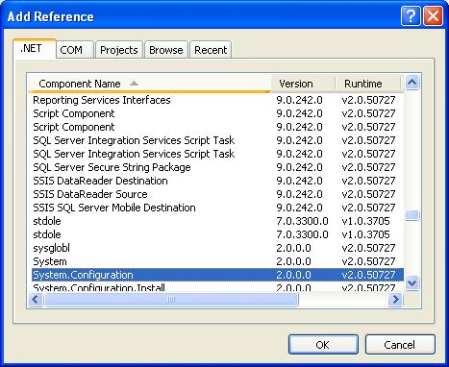

Note: If you don't add this reference you will see an error like this when you compile:
The type System.Configuration.ConfigurationSection is defined in an assembly that is not referenced. You must add a reference to assembly System.Configuration
- The <listeners> section of the app.config file allows you to specify a file you want logging information sent to. For example, the following writes trace information to WFHOLTrace.log in the same directory as the executable. This file is not truncated on each run of your application so it will grow in size.
<listeners>
<add name="myListener" type="System.Diagnostics.TextWriterTraceListener"
initializeData="WFHOLTrace.log" />
</listeners>
- If you want to select the type of information that gets logged to your trace file you can selectively turn on or off 5 classes of information. The WorkflowRuntime logs the following types of information, Runtime, Tracking, Host, Activity and LogTraces. Tracing is off by default so in order to turn it on you need the <switches> section in your .config file.
<system.diagnostics>
<switches>
<add name="WorkflowTraceToDefault" value="1" />
<add name="Host" value="All" />
<add name="Runtime" value="All" />
<add name="Tracking" value="All" />
<add name="Activity" value="All" />
</switches>
<trace autoflush="true" indentsize="4">
<listeners>
<add name="myListener"
type="System.Diagnostics.TextWriterTraceListener"
initializeData="WFHOLTrace.log" />
</listeners>
</trace>
</system.diagnostics>
- In order to use your config file you need to tell the runtime where to look. To do that we make a slight change when we declare and initialize our WorkflowRuntime variable. We change the first line of the Main method in Module1.vb from this:
Using workflowRuntime As New WorkflowRuntime()

to this:
Using workflowRuntime As New WorkflowRuntime("ConsoleApplication")
- This tells the runtime to look in the config file for a <section> with the name "ConsoleApplication". Within the <Services> tag you can add individual services you want available along with some of their configuration information such as a connection string for Microsoft SQL Server.
<configSections>
<section name="ConsoleApplication"
type="System.Workflow.Runtime.Configuration.
WorkflowRuntimeSection,
System.Workflow.Runtime, Version=3.0.00000.0, Culture=neutral,
PublicKeyToken=31bf3856ad364e35" />
</configSections>
- Run your application by pressing F5. When you run your application using a config file and print out the services loaded you will see something like this:

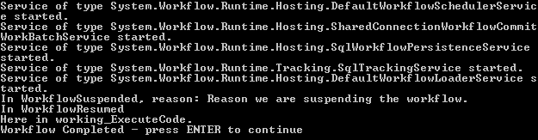

Note:
If SQL Server or SQL Express is not running, the window will stay blank for 15 seconds until the database connection times out. Also, if the database and database objects have not been set up you see other errors. The SQL scripts for all the database objects needed for Lab03 are in the Lab03\Resources directory. The batch file CreateDatabaseObjects.cmd will create all the database objects you need so running it should correct any errors you receive if the database has not been created.

- To setup a SqlTrackingService instance from code you would first remove the Application Configuration file and the following highlighted changes from the Main Method. Remove the “ConsoleApplication” parameter from the WorkflowRuntime instantiation.
Using workflowRuntime As New WorkflowRuntime("ConsoleApplication")

to this:
Using workflowRuntime As New WorkflowRuntime()
- Add the following code inside the using statement.

(Snippet: “Lab03 Ex01 Task03 SqlTrackingAddService”)
Dim connectionString As String = "Initial Catalog=TrackingStore; " & _
"Data Source=localhost\\SQLEXPRESS; " & "Integrated Security=SSPI;"
workflowRuntime.AddService(New System.Workflow.Runtime.Tracking.SqlTrackingService(connectionString))

- Press F5 and the output should look like this:

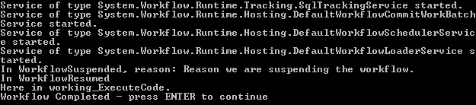

Exercise 2 – Using the default SQL Services

In this exercise we will show you how to use the SqlTrackingService with your workflows. The SqlTrackingService logs relevant information to a database which you can retrieve later.

Window Workflow Foundation provides a SQL Server based tracking service. During execution of a workflow certain events are emitted by the runtime. The tracking service can catch these events and store that event information in a SQL Server database.

There are three types of events:
- Workflow Events – These events are emitted by the engine when a workflow instance enters into a particular state. For example, an event is raised when the workflow instance is 'Initialized' or when the workflow instance is 'Executing'.
- Activity Level Events – A workflow is made up of activities and each activity goes through a lifecycle. During its lifecycle the activity passes through multiple states. Whenever an activity reaches a particular state an event is raised.
- User Tracked events – If a workflow author would like to add additional information he can add custom tracking events in a workflow's code beside.

Along with the events, data from the workflow data context can also be emitted and given to the tracking service.

All the events for all the states of the instance as well as activities are not always of interest. You can specify the events you are interested in along with the data that is of interest to you in a tracking profile. The SQL tracking service has a default tracking profile. This example demonstrates the use of the SQL tracking service with the default tracking profile.

Task 1 – Create a new Console Application Project.

- Open Visual Studio 2005 by going to the Start Menu | All Programs | Microsoft Visual Studio 2005 | Microsoft Visual Studio 2005.
- In Visual Studio 2005, select the File | New | Project menu command.
- Visual Studio will display the New Project dialog window.
- In the New Project dialog window, expand Visual Basic | Workflow in the Project Types tree on the left side.
- Select “Sequential Workflow Console Application”.

Name: DefaultSQLServices

Location: c:\Windows Workflow Foundation\Labs\VB\Lab03\

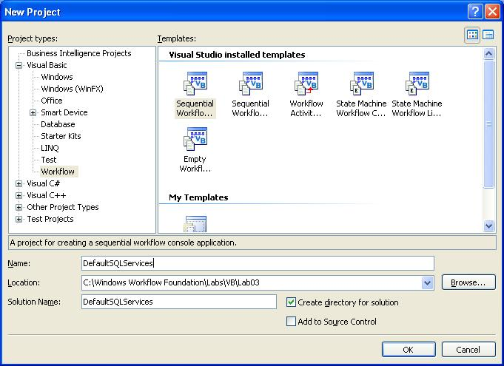
- Click OK to create the new solution.
- Right Click on Workflow1.vb in the solution explorer and Rename it to SimpleWorkflow.vb.

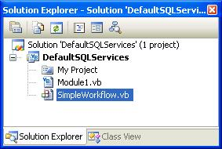
- Press Yes if prompted to rename all instances of Workflow1

- Double click on SimpleWorkflow.vb to view the designer, and drop a Code activity on the workflow where it states Drop Activities to create a Sequential Workflow.
- Right Click on codeActivity1, select Properties, set the (Name) property to working.

- Double click on the working Code activity, to produce a default event handler.
- When the workflow is executed the code handler for working will be called so let's just add a simple Console.WriteLine statement to working_ExecuteCode so that we know the function was called. Add the line of code highlighted in gray:
Private Sub working_ExecuteCode(ByVal sender As System.Object, ByVal e As System.EventArgs)
Console.WriteLine("Here in Working_ExecuteCode.")
End Sub

Task 2 – Adding the SQLTrackingService to the host environment

- Double Click on Module1.vb in the solution explorer to bring it into the code editor.
- Create a private static member within the Program class that contains the connection string to the TrackingStore.
Shared connectionString As String = "Initial Catalog=TrackingStore;" & _
"Data Source=localhost\SQLExpress; Integrated Security=SSPI;"
- Inside Module1.vb insert the following Imports directives above the class definition.

(Snippet: “Lab03 Ex02 Task02 Usings”)
Imports System.Workflow.Runtime.Tracking
Imports System.Data
Imports System.Data.SqlClient
Imports System.Data.SqlTypes
- Add the SqlTrackingService to the workflow, underneath the workflowRuntime instansiation by adding the following grey highlighted line of code.

Using workflowRuntime As New WorkflowRuntime()
workflowRuntime.AddService(New SqlTrackingService(connectionString))
- Remove WaitHandle.WaitOne() invocation at the end of the Main method.
Dim workflowInstance As WorkflowInstance workflowInstance = workflowRuntime.CreateWorkflow(GetType(SimpleWorkflow))
workflowInstance.Start()
WaitHandle.WaitOne()
- Insert the following highlighted code into the Main method after the workflow instance invocation.

(Snippet: “Lab03 Ex02 Task02 InvokeTracking”)
Dim workflowInstance As WorkflowInstance workflowInstance = workflowRuntime.CreateWorkflow(GetType(SimpleWorkflow))
workflowInstance.Start()
workflowInstance.Suspend("Reason we are suspending the workflow.")
workflowInstance.Resume()

WaitHandle.WaitOne()

GetInstanceTrackingEvents(workflowInstance.InstanceId)

Console.WriteLine("Workflow Completed - press ENTER to continue")
Console.Read()
- GetInstanceTrackingEvents will pull information about the workflow itself. Insert this code below the Main method in the Program class.

(Snippet: “Lab03 Ex02 Task02 InstanceTracking”)
Shared Sub GetInstanceTrackingEvents(ByVal instanceId As Guid)

Console.WriteLine("" & vbCrLf & "Instance Tracking Events :")

Dim sqlTrackingQuery1 As SqlTrackingQuery = New SqlTrackingQuery(connectionString)
Dim sqlTrackingWorkflowInstance1 As SqlTrackingWorkflowInstance
sqlTrackingQuery1.TryGetWorkflow(instanceId, sqlTrackingWorkflowInstance1)

Try
For Each workflowTrackingRecord As WorkflowTrackingRecord In _ sqlTrackingWorkflowInstance1.WorkflowEvents
Console.WriteLine("EventDescription : {0} DateTime : {1}", _
workflowTrackingRecord.TrackingWorkflowEvent, _ workflowTrackingRecord.EventDateTime)
Next
Catch e As Exception
Console.WriteLine("No Instance Tracking Events Found")
End Try
End Sub
- Press F5 to run the application and you should see output similar to this:

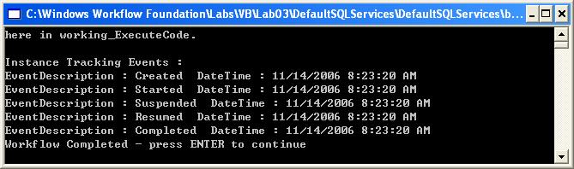

Task 3 – Adding the SQLPersistenceService to the host environment
Many business processes that can be implemented as workflows take long periods of time to complete (up to many months or even years). Holding the workflow in memory is not only impractical (what happens if the server needs to be restarted?), but also prevents scaling because an instance must be processed on a single server and takes up memory and other resources on that server. Many of these long-running workflows are not actively executing flow or process logic and are effectively idle, waiting for input from users or other systems. By unloading an idle instance, the host application can save memory and enable scalability across processing servers. This sample demonstrates how to unload an idle instance with a simple workflow that waits for five seconds before completing.

Modify your existing Workflow to output the current time before and after a delay:
- Double Click on SimpleWorkflow.vb to bring it into the designer
- Delete the working CodeActivity from SimpleWorkflow by right-clicking on it and selecting Delete.
- Drop two Code Activities on the Workflow design surface, set their (Name) property to timeBefore and timeAfter respectfully.
- Drop one Delay Activity in-between them and set its (Name) property to delay.
- Your Workflow design surface should look like the following:
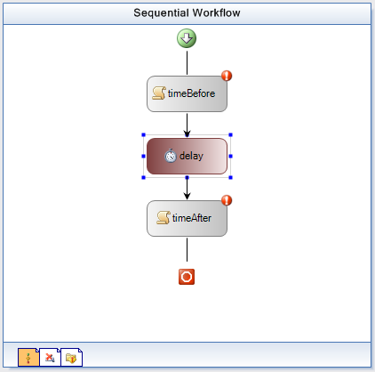
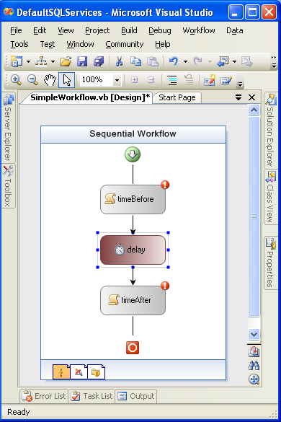

- Double-click on timeBefore to create a event handler, and add the following grey highlighted code.

Private Sub timeBefore_ExecuteCode(ByVal sender As System.Object, ByVal e As System.EventArgs)
Console.WriteLine("before delay: '{0}'", DateTime.Now.ToLongTimeString())
End Sub
- Double click on SimpleWorkflow.vb to view the designer.
- Double click on timeAfter to create a event handler, and add the following code.

Private Sub timeAfter_ExecuteCode(ByVal sender As System.Object, ByVal e As System.EventArgs)
Console.WriteLine("after delay: '{0}'", DateTime.Now.ToLongTimeString())
End Sub
- Double click on SimpleWorkflow.vb to view the designer.
- Right Click on delay select Properties
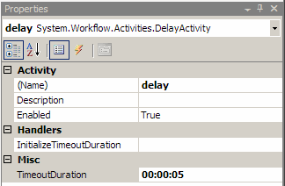
- Set TimeoutDuration on delay to 5 seconds as in this image.

- Double Click on Module1.vb to bring it into the code window.
- The workflow runtime has a default Sql Commit Work Batch Service for accessing the database in a consistent way. We will add a service that replaces it and assumes that all database connections are the same. This means that it will avoid using the DTC and improve our database performance. This is useful when you are using both the SQL Persistence Service and the SQL Tracking Service with an identical database connection string.
- Add the following below the WorkflowRuntime instantiation.

Using workflowRuntime As New WorkflowRuntime()
workflowRuntime.AddService(New SharedConnectionWorkflowCommitWorkBatchService(connectionString))
- Add the following call to add a SqlWorkflowPersistenceService below the existing AddService calls in the Main method. The SqlWorkflowPersistenceService instantiation allows us to persist workflows to the database.

workflowRuntime.AddService(New SqlTrackingService(connectionString))
workflowRuntime.AddService(New SqlWorkflowPersistenceService(connectionString, True, _
New TimeSpan(0, 0, 0, 10, 0), New TimeSpan(0, 0, 0, 10, 0)))
- Add the following gray highlighted delegates into the Main method below the existing delegates.
(Snippet: “Lab03 Ex02 Task03 Delegates”)

AddHandler workflowRuntime.WorkflowCompleted, AddressOf OnWorkflowCompleted
AddHandler workflowRuntime.WorkflowTerminated, AddressOf OnWorkflowTerminated
AddHandler workflowRuntime.WorkflowLoaded, AddressOf OnWorkflowLoaded
AddHandler workflowRuntime.WorkflowIdled, AddressOf OnWorkflowIdled
AddHandler workflowRuntime.WorkflowPersisted, AddressOf OnWorkflowPersisted
AddHandler workflowRuntime.WorkflowUnloaded, AddressOf OnWorkflowUnloaded
- Add the following event handlers into the Program class after the Main method.
(Snippet: “Lab03 Ex02 Task03 EventHandlers”)
Shared Sub OnWorkflowIdled(ByVal sender As Object, ByVal e As WorkflowEventArgs)
Console.WriteLine("Workflow {0} idled", e.WorkflowInstance.InstanceId)
ThreadPool.QueueUserWorkItem(AddressOf UnloadInstance, e.WorkflowInstance)
End Sub

Shared Sub OnWorkflowUnloaded(ByVal sender As Object, ByVal e As WorkflowEventArgs)
Console.WriteLine("Workflow {0} unloaded", e.WorkflowInstance.InstanceId)
End Sub

Shared Sub OnWorkflowPersisted(ByVal sender As Object, ByVal e As WorkflowEventArgs)
Console.WriteLine("Workflow {0} persisted", e.WorkflowInstance.InstanceId)
End Sub

Shared Sub OnWorkflowLoaded(ByVal sender As Object, ByVal e As WorkflowEventArgs)
Console.WriteLine("Workflow {0} loaded", e.WorkflowInstance.InstanceId)
End Sub
- You may have noticed a call to UnloadInstance during the WorkflowIdled event, add this code below the Main method inside the Program class.
(Snippet: “Lab03 Ex02 Task03 UnloadInstance”)
Shared Sub UnloadInstance(ByVal workflowInstance As Object)
Dim instance As WorkflowInstance = CType(workflowInstance, WorkflowInstance)

Try
Console.WriteLine("UnloadInstance: attempting to unload \'{0}\'", instance.InstanceId) I instance.Unload()
Catch ex As Exception
Console.WriteLine("UnloadInstance: failed " & vbCrLf & "{0}", ex)
End Try
End Sub
- Make sure SQL Server or SQL Express is running, press F5 and you should see output similar to this:

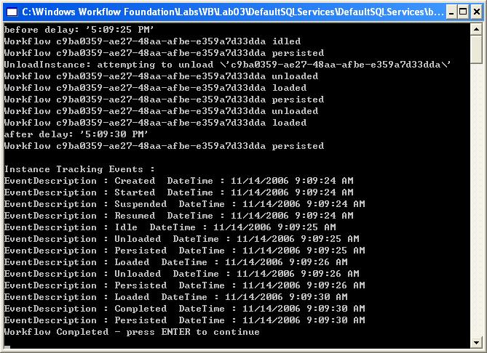

Task 4 – Adding a WorkflowSchedulerService to the host environment
A WorkflowSchedulerService decides how and when to load and persist running workflows. By default Windows Workflow Foundation will use the DefaultWorkflowSchedulerService however you can choose to use anything that inherits from WorkflowSchedulerService.
Workflow Foundation already comes with two types of SchedulerServices, DefaultWorkflowSchedulerService and ManualWorkflowSchedulerService, note if you do not specify a type of WorkflowSchedulerService through use of an application configuration file or manually making a call to AddService; DefaultWorkflowSchedulerService will be used.
- Double Click on SimpleWorkflow.vb to bring it into the designer.
- Delete timeBefore, delay, and timeAfter by right clicking and selecting delete for each activity.
- Drop a new code activity on the designer and set the (Name) property to code, your design surface should look like this.

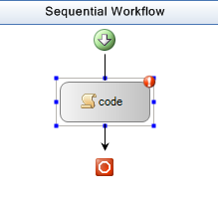

- Double Click on code to create a default error handler, add the following gray highlighted code.

Private Sub code_ExecuteCode(ByVal sender As System.Object, ByVal e As System.EventArgs)
Console.WriteLine("Here in Code_ExecuteCode.")
System.Threading.Thread.Sleep(New TimeSpan(0, 0, 2))
End Sub

- Double Click on Module1.vb to bring it into the code window.
- Insert the following call to add a DefaultWorkflowSchedulerService below the existing AddService calls. Note the 1 in the DefaultWorkflowSchedulerService instantiation ensures that it will only allow a single Workflow to be executed at any single point in time.
workflowRuntime.AddService(New SqlWorkflowPersistenceService(connectionString, True, _
New TimeSpan(0, 0, 0, 10, 0), New TimeSpan(0, 0, 0, 10, 0)))
workflowRuntime.AddService(New DefaultWorkflowSchedulerService(1))
- Replace the following lines.
Dim workflowInstance As WorkflowInstance
workflowInstance = workflowRuntime.CreateWorkflow(GetType(DefaultSQLServices.SimpleWorkflow))
workflowInstance.Start()

workflowInstance.Suspend("Reason we are suspending the workflow.")
workflowInstance.Resume()

WaitHandle.WaitOne()

GetInstanceTrackingEvents(workflowInstance.InstanceId)
- With the following code to start up 5 instances of our simpleWorkflow workflow.
(Snippet: “Lab03 Ex02 Task04 InvokeMulti”).
Dim workflowCount As Integer = 0
Do While (workflowCount < 5)
Dim simpleWorkflowInstance As WorkflowInstance = _
workflowRuntime.CreateWorkflow(GetType(DefaultSQLServices.SimpleWorkflow))
simpleWorkflowInstance.Start()
workflowCount = (workflowCount + 1)
Loop

System.Threading.Thread.Sleep(New TimeSpan(0, 0, 20))
- Press F5 and you should see output similar to this:

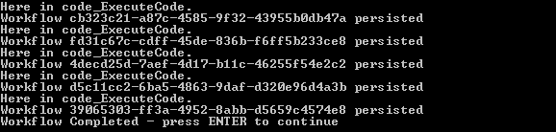

As expected you can see that the workflows are being executed one after the other, which is because we have specified that our DefaultWorkflowScheduler only allow a single workflow to execute at any point in time.

- Remove the parameter from the constructor of the DefaultWorkflowShedulerService class.
workflowRuntime.AddService(new DefaultWorkflowSchedulerService());
- Press F5 and you should see output similar to this:

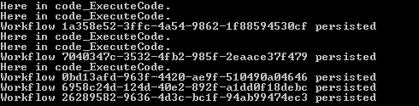

As expected you can see that the workflows are being executed concurrently as our DefaultWorkflowScheduler doesn’t have any specific limit to concurrent threads to run.

Exercise 3 – Building a Custom TrackingService for Workflow Monitoring

Windows Workflow Foundation provides a tracking infrastructure that enables applications to track workflow state changes and data. In addition, it gives you the flexibility to create the most appropriate tracking services for your business needs and use those tracking services in the runtime.

To write a tracking service, you need to implement a TrackingChannel and a TrackingService. The TrackingChannel receives the various tracking records sent by the runtime. The TrackingService provides the runtime with tracking profiles based on specific parameters and conditions. It is also responsible for providing a TrackingChannel that receives the data sent by the runtime.

Task 1 – Create a new Console Application Project

- Open Visual Studio 2005 by going to the Start Menu | All Programs | Microsoft Visual Studio 2005 | Microsoft Visual Studio 2005.
- In Visual Studio 2005, select the File | New | Project menu command.
- Visual Studio will display the New Project dialog window.
- In the New Project dialog window, expand Visual Basic | Workflow in the Project Types tree on the left side.
- Select Sequential Workflow Console Application.

Name: ConsoleTrackingServiceSample

Location: c:\Windows Workflow Foundation\Labs\VB\Lab03\
- Click OK to create the project.
- Right Click on Workflow1.vb in the solution explorer and Rename it to SimpleWorkflow.vb.

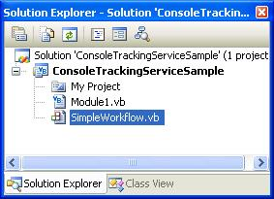

- Press Yes if prompted to rename all instances of Workflow1

- Double click on SimpleWorkflow in the Solution Explorer to view the designer, and drop a Code activity on the workflow where it states Drop Activities to create a Sequential Workflow.
- Right Click on codeActivity1 select Properties set the (Name) property to working.
- Double click on working Code activity, to produce a default event handler.
- When the workflow is executed the code handler for working will be called so let's just add a simple Console.WriteLine statement to working _ExecuteCode so that we know the function was called. Add the line of code highlighted in gray:

Private Sub working_ExecuteCode(ByVal sender As System.Object, ByVal e As System.EventArgs)
Me.TrackData("Hello - this is a UserTrackPoint")
End Sub

Task 2 – Create our ConsoleTrackingChannel

The TrackingChannel abstract class serves as a conduit that receives tracking events and data for a single workflow instance. The purpose of TrackingChannel is to provide a mechanism for tracking service writers to receive tracking information without concern for thread safety. Because each workflow instance has only one thread of execution there is never more than one thread active in a TrackingChannel object at any given time alleviating the need for data synchronization.

- Right click on the ConsoleTrackingServiceSample project select Add | New Item.
- Select Code File and change the name from CodeFile1.vb to ConsoleTrackingChannel.vb.

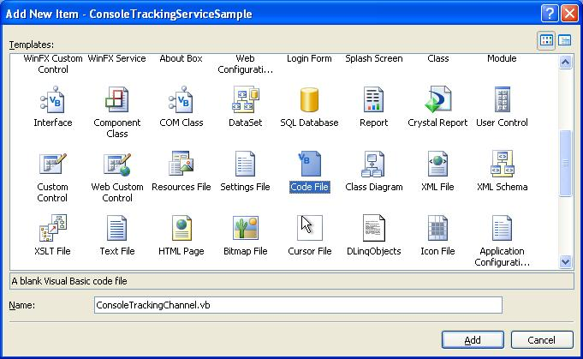

- Any Tracking Channel must inherit from the TrackingChannel class so add the following code to declare our ConsoleTrackingChannel as a subclass of TrackingChannel and to setup necessary constructors.

(Snippet: “Lab03 Ex03 Task02 TrackingChannel”)
Imports System
Imports System.IO
Imports System.Workflow.Runtime
Imports System.Workflow.Runtime.Tracking
Imports System.Workflow.ComponentModel
Imports System.Workflow.Runtime.Hosting

Public Class ConsoleTrackingChannel
Inherits TrackingChannel

Private parameters As TrackingParameters = Nothing

Protected Sub New()
MyBase.new()
End Sub

Public Sub New(ByVal parameters As TrackingParameters)
MyBase.New()
Me.parameters = parameters
End Sub
Protected Overrides Sub InstanceCompletedOrTerminated()

End Sub

End Class
- The runtime tracking infrastructure calls Send to deliver a TrackingRecord on the TrackingChannel when it matches a track point in a TrackingProfile. We will implement the Send method as follows – add this code inside the ConsoleTrackingChannel class.

(Snippet: “Lab03 Ex03 Task02 SendLogic”)
Protected Overrides Sub Send(ByVal record As TrackingRecord)
' filter on record type
If (TypeOf (record) Is WorkflowTrackingRecord) Then
WriteWorkflowTrackingRecord(CType(record, WorkflowTrackingRecord))
End If
If (TypeOf (record) Is ActivityTrackingRecord) Then
WriteActivityTrackingRecord(CType(record, ActivityTrackingRecord))
End If
If (TypeOf (record) Is UserTrackingRecord) Then
WriteUserTrackingRecord(CType(record, UserTrackingRecord))
End If
End Sub
- For each of the differing types of TrackingRecord we will be outputting some details about that record, so add the following supporting code into the ConsoleTrackingChannel class.

(Snippet: “Lab03 Ex03 Task02 Support”)
#Region "support-code"

Private Shared Sub WriteTitle(ByVal title As String)
Console.WriteLine(vbLf & "******************************************")
Console.WriteLine(vbTab & title)
Console.WriteLine("******************************************")
End Sub

Private Shared Sub WriteWorkflowTrackingRecord(ByVal workflowTrackingRecord As WorkflowTrackingRecord) WriteTitle("Workflow Tracking Record")
Console.WriteLine("EventDateTime: " & workflowTrackingRecord.EventDateTime.ToString)
Console.WriteLine("Status: " & workflowTrackingRecord.TrackingWorkflowEvent.ToString)
End Sub

Private Shared Sub WriteActivityTrackingRecord(ByVal activityTrackingRecord As ActivityTrackingRecord)
WriteTitle("Activity Tracking Record")
Console.WriteLine("EventDateTime: " & activityTrackingRecord.EventDateTime.ToString)
Console.WriteLine("QualifiedName: " & activityTrackingRecord.QualifiedName.ToString)
Console.WriteLine("Type: " & activityTrackingRecord.ActivityType.ToString)
Console.WriteLine("Status: " & activityTrackingRecord.ExecutionStatus.ToString)
End Sub

Private Shared Sub WriteUserTrackingRecord(ByVal userTrackingRecord As UserTrackingRecord)
WriteTitle("User Activity Record")
Console.WriteLine("EventDateTime: " & userTrackingRecord.EventDateTime.ToString)
Console.WriteLine("QualifiedName: " & userTrackingRecord.QualifiedName.ToString)
Console.WriteLine("ActivityType: " & userTrackingRecord.ActivityType.FullName.ToString)
Console.WriteLine("Args: " & userTrackingRecord.UserData.ToString)
End Sub

#End Region
- InstanceCompletedOrTerminated is called by the tracking runtime to indicate that the workflow instance finished running, regardless of the tracking profile associated with that instance, we will implement this method by writing a message to the console, add this code inside the ConsoleTrackingChannel class.

(Snippet: “Lab03 Ex03 Task02 CompleteTerminated”)
Protected Overrides Sub InstanceCompletedOrTerminated()
WriteTitle("Workflow Instance Completed or Terminated")
End Sub

Task 3 – Create our ConsoleTrackingService

Tracking services are designed to monitor workflow execution through the exchange of data that can then be persisted to a storage medium or output on a specified stream, the System.Console for instance.
- Right click on ConsoleTrackingServiceSample select Add | New Item.
- Select Code File and change the name from CodeFile1.vb to ConsoleTrackingService.vb.
- Add the following code to declare our ConsoleTrackingService as a descendant of TrackingService.

(Snippet: “Lab03 Ex03 Task03 TrackingService”).
Imports System
Imports System.IO
Imports System.Workflow.Runtime
Imports System.Workflow.Runtime.Tracking
Imports System.Workflow.ComponentModel
Imports System.Workflow.Runtime.Hosting

Public Class ConsoleTrackingService
Inherits TrackingService

Protected Overloads Overrides Function GetProfile(ByVal workflowInstanceId As System.Guid) As System.Workflow.Runtime.Tracking.TrackingProfile

End Function

Protected Overloads Overrides Function GetProfile(ByVal workflowType As System.Type, ByVal profileVersionId As System.Version) As System.Workflow.Runtime.Tracking.TrackingProfile

End Function
Protected Overrides Function GetTrackingChannel(ByVal parameters As System.Workflow.Runtime.Tracking.TrackingParameters) As System.Workflow.Runtime.Tracking.TrackingChannel

End Function

Protected Overrides Function TryGetProfile(ByVal workflowType As System.Type, ByRef profile As System.Workflow.Runtime.Tracking.TrackingProfile) As Boolean

End Function

Protected Overrides Function TryReloadProfile(ByVal workflowType As System.Type, ByVal workflowInstanceId As System.Guid, ByRef profile As System.Workflow.Runtime.Tracking.TrackingProfile) As Boolean

End Function

End Class

One by one we will write code to implement these stubs, add the following code into their specific methods.
- GetProfile(ByVal WorkflowInstanceId As System.Guid), we don’t support reloading / instance profiles so we throw an exception.
Throw New NotImplementedException("The method or operation is not implemented.")
- GetProfile(ByVal workflowType As System.Type, ByVal profileVersionId As System.Version), we return a version of the tracking profile that the runtime requests.
Return GetProfile()
- GetTrackingChannel(…),we return our ConsoleTrackingChannel.
Return New ConsoleTrackingChannel(parameters)
- TryGetProfile(…),depending on the workflow type, we can return different tracking profiles, in this lab we return the same profile for all running types.
profile = GetProfile()
Return True
- TryReloadProfile(…), we return false to indicate that there are no new profiles.
profile = Nothing
Return False
- You may have noticed a call to a method called GetProfile, this method (code below) is responsible for creating a TrackingProfile, setting up events for notification of ActivityTrackPoint, WorkflowTrackPoint Status Events, and UserTrackPoints. Add it to the class.

(Snippet: “Lab03 Ex03 Task03 GetProfile”)
Private Overloads Shared Function GetProfile() As TrackingProfile
' Create a Tracking Profile
Dim profile As TrackingProfile = New TrackingProfile
profile.Version = New Version("3.0.0")

' Add a TrackPoint to cover all activity status events
Dim activityTrackPoint As ActivityTrackPoint = New ActivityTrackPoint
Dim activityLocation As ActivityTrackingLocation = New ActivityTrackingLocation(GetType(Activity))
activityLocation.MatchDerivedTypes = True
For Each status As ActivityExecutionStatus In System.Enum.GetValues(GetType(ActivityExecutionStatus))
activityLocation.ExecutionStatusEvents.Add(status)
Next
activityTrackPoint.MatchingLocations.Add(activityLocation)
profile.ActivityTrackPoints.Add(activityTrackPoint)

' Add a TrackPoint to cover all workflow status events
Dim workflowTrackPoint As WorkflowTrackPoint = New WorkflowTrackPoint
workflowTrackPoint.MatchingLocation = New WorkflowTrackingLocation
For Each workflowEvent As TrackingWorkflowEvent In _
System.Enum.GetValues(GetType(TrackingWorkflowEvent))
workflowTrackPoint.MatchingLocation.Events.Add(workflowEvent)
Next
profile.WorkflowTrackPoints.Add(workflowTrackPoint)

' Add a TrackPoint to cover all user track points
Dim userTrackPoint As UserTrackPoint = New UserTrackPoint
Dim userLocation As UserTrackingLocation = New UserTrackingLocation
userLocation.ActivityType = GetType(Activity)
userLocation.MatchDerivedActivityTypes = True
userLocation.ArgumentType = GetType(System.Object)
userLocation.MatchDerivedArgumentTypes = True
userTrackPoint.MatchingLocations.Add(userLocation)
profile.UserTrackPoints.Add(userTrackPoint)

Return profile
End Function

Task 4 – Run ConsoleTrackingServiceSample

- Double click on Module1.vb to bring up the code window.
- Add the following line of code just below the WorkflowRuntime using directive.

Using workflowRuntime As New WorkflowRuntime()
workflowRuntime.AddService(New ConsoleTrackingService())
- Add the following code at the end of the main method.
Console.WriteLine("Workflow Completed - press ENTER to continue")
Console.Read()
- Select the Debug | Start Debugging menu command.
- You will see output similar to this:

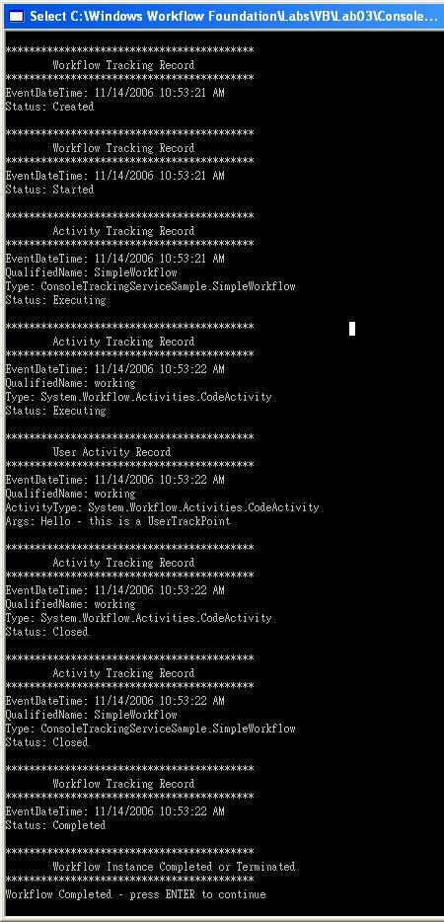
Lab Summary

The objective of this lab was to introduce you to hosting the Workflow Foundation runtime and responding to some of its events. In the lab you learned how to:

Host Workflow Foundation in a simple Windows console application and start a workflow using the Workflow Foundation runtime.
Run the console application to verify that workflow was loaded, ran successfully and that the runtime events were raised.
Used the SQLTracking service to log runtime and instance events and retrieve them from the database.
Used the SQLPersistenceService to persist the state of our workflows to a database and have them retrieved when they were required.
Used the WorkflowSchedulerService to customize the execution of a group of workflows
Built a Custom TrackingService for Workflow Monitoring

